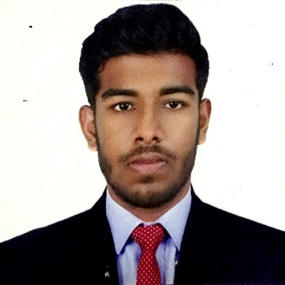

CURRICULUM VITAE

MOHAMMAD KHAMBATY
MOBILE NO 055-9169551
EMAIL:Mohammedkhambaty91@gmail.com

CAREER OBJECTIVES
Seeking a challenging opportunity to deliver my skills and potentials which can be extensively applied and allows me to learn new environments and concepts for my career growth

WORKING EXPERIENCE

Worked as a Supervisor mystery shopping
Company: TNS
Duration : 2 years

Sale executive
Company: Rutwa tourism
Duration:4months

Sale promoter in Adidas
Company : Dulsco
Duration : one month

Site supervisor in AFC 2019
Company: WOW events
Duration : 1months

Sale promoter in Apple Accessories
Company:DNS
Duration: one month

Gitex in Four mobile in 2017
Company: Red frame production
Duration: five days

Sale Promoter in Dell
Company: Just BTL
Duration : 2 months

Sale promoter in Transfast world wide money transfer
Company: Transfast
Duration :15days

Sale promoter in Gitex 2018
Company: Four mobile
Duration:8days

Transport coordinator
Company : Motus One
Duration : depends on event

PROFILE

- Patient, good listener, dedicated to serve people
- Good at Accounts and relevant software works (Computers)
- Team player, Friendly and well adaptable to work conditions
- Knowledge of system, Good to Handle situations, Honest and Efficient

EDUCATION
- 10 + 2 pattern from GULF INDIAN HIGH SCHOOL, CBSE LEVEL, DUBAI – UAE (2015-2016) passing with 78.6%
- Diploma in computer programming
- Good knowledge on MS Word, Excel, Power Point &amp; Web browsing.
- Bachelor of business administrative from Bucks University (UK)

STRENGTH
- Optimistic Team-spirited and Excellent result focused
- Hard Working, very punctual and committed to the careers
- Can work under pressure and yet produce efficient result
- Fast learning capacity
- Ability to build and maintain customer relation

IT SkILLS

- Microsoft Office (Word, Excel, Power point)
- Proficient in accounts software
- Proficient in Internet Browsing

LANGUAGES

- ENGLISH – READ,WRITE & SPEAK (Fluent)
- HINDI – READ, WRITE & SPEAK
- ARABIC – READ & WRITE ONLY
- GUJRATHI
HOBBIES & Interests

- Chatting, communicating with people of Different Cultures/Places
- Sports, Music, Travelling, Surfing Net
- Reading Books, Swimming & Watching Movies

PERSONAL PROFILE

- Date of Birth – 10-06-1998
- Nationality – Indian
- Sex – Male, Single
- Religion – Islam
- Driving license : yes
- Visa Status – Father sponsorship
- Nationality - INDIAN

I, hereby Mohammed Khambaty affirm that the information written is precise and accurate.
=========================================================

